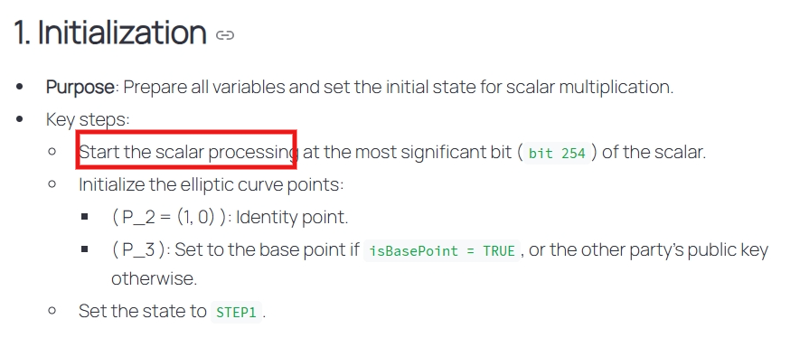
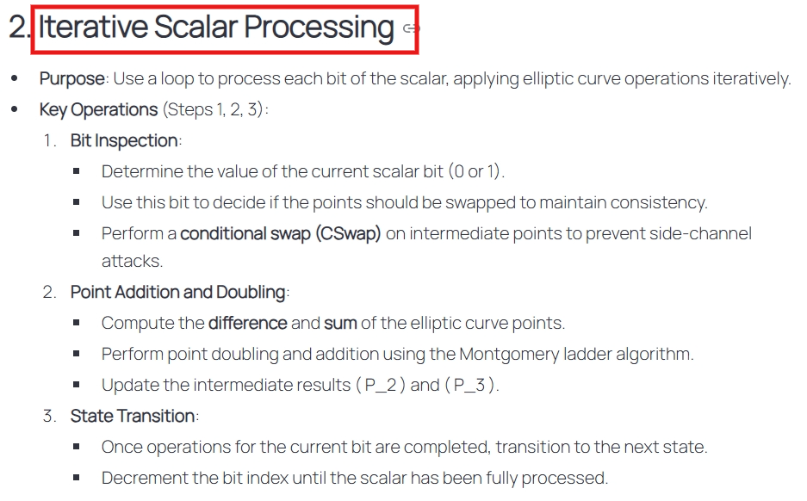
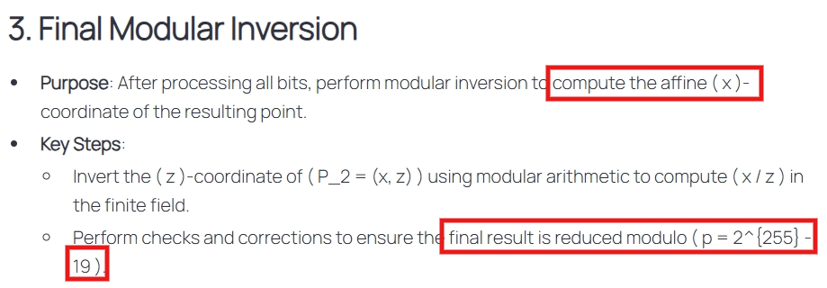
Elements must be in range (0, p-1) according to NIST
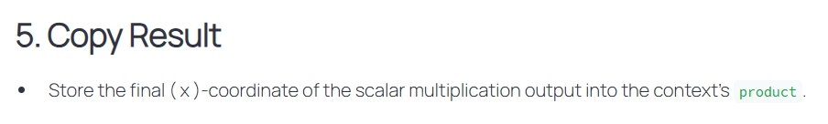

- Then convert from Limbs (machine words) to uint8_t for shared secrets

